LOAN ELIGIBILITY PREDICTION
BACHELOR OF TECHNOLOGY
IN
COMPUTER SCIENCE AND ENGINEERING
BY
Y. Chaitanya | 24501A05P5
T. Likitha | 24501A05N2
S. Rohit | 24501A05M4
S. DivyaSri | 24501A05L8

PRASAD V POTLURI SIDDHARTHA INSTITUTE OF TECHNOLOGY
(Permanently affiliated to JNTU Kakinada, Approved by AICTE)
(An NBA & NAAC A+ accredited and ISO 21001:2018 Certified Institution)
Kanuru, Vijayawada – 520007
(2026-27)

PRASAD V POTLURI
SIDDHARTHA INSTITUTE OF TECHNOLOGY
(Permanently affiliated to JNTU Kakinada, Approved by AICTE)
(An NBA & NAAC accredited and ISO 21001:2018 certified institution)
Kanuru, Vijayawada – 520007
CERTIFICATE
This is to certify that the project report titled “Loan Eligibility Prediction” is the bonafide work of Y. Chaitanya (24501A05P5), T. Likitha (24501A05N2), S. Rohit (24501A05M4), S. DivyaSri (24501A05L8) in partial fulfilment of completing the Academic project in Data Mining during the academic year 2026-27.
Signature of the course coordinator Signature of the HOD

I N D E X
S.No. | Content | Page No.s
1 | Abstract | 1
2 | Introduction | 2
3 | Project Design | 3
4 | Dataset Overview | 4 - 5
5 | Data Preprocessing | 6 - 7
6 | Model Training and Hyperparameter Tuning | 8 - 11
7 | Model Evaluation and Selection | 12 - 14
8 | Web Application Implementation | 15 - 16
9 | Conclusion | 17
10 | References | 18

1. Abstract
This machine learning project aimed to develop and deploy an intelligent Loan Eligibility Prediction System that helps banks, financial institutions and loan applicants make faster, more consistent and data-driven lending decisions. Traditional loan screening depends heavily on manual document verification, which is slow, subjective and prone to inconsistency. The proposed system replaces this with a web-based tool that instantly estimates whether an applicant is likely to be approved, how much loan the applicant is eligible for, and what the monthly instalment would be.
The system is built as a Flask web application, hosted online at https://loan-eligibility-project-sstz.onrender.com/. It includes a secure multi-user authentication module (registration and login with hashed passwords stored using Werkzeug security) and a protected loan eligibility form. The applicant provides ten input features: Monthly Income, Employment Type, Credit Score, Existing Loans Count, Existing Monthly EMI, Dependents, Savings Balance, Loan Type, Requested Amount and Tenure (in months). These inputs are sent as JSON to a /predict REST endpoint, where two pre-trained scikit-learn models are loaded using joblib.
The first model is a classification model that outputs the Approval Probability of the application. The second is a regression model that predicts the Eligible Loan Amount. Using the predicted eligible amount and the requested tenure, the application then calculates the Estimated Monthly EMI with the standard reducing-balance EMI formula at an annual interest rate of 10.5%.
The dataset of loan applicant records was pre-processed by handling missing values, encoding categorical features (Employment Type and Loan Type) and applying Z-Score normalization to numerical features. The data was split in an 80:20 train-test ratio, and multiple algorithms were trained and tuned using Grid Search with 5-fold cross-validation. Classification performance was assessed using Accuracy, Precision, Recall, F1-Score and ROC-AUC, while the loan amount model was assessed using RMSE and the R² Score. The best-performing model was XG Boost Classifier for approval prediction (Accuracy 95.00%) and XG Boost Regressor for eligible amount prediction (R² 0.7609), and both were saved as loan_approval_model.pkl and loan_amount_model.pkl for deployment.

2. Introduction

2.1 Background
Lending is one of the core activities of the banking and financial sector. Every day, banks and non-banking financial companies receive thousands of applications for home loans, personal loans, education loans, vehicle loans and business loans. Before sanctioning a loan, the lender must judge the applicant’s repayment capacity by examining income, employment stability, credit history, existing liabilities, family responsibilities and savings. Doing this manually is time-consuming, depends on the experience of the individual loan officer, and can lead to inconsistent or biased decisions.
Loan defaults are costly. When a loan is approved for an applicant who cannot repay it, the lender suffers financial loss and rising non-performing assets; when a genuine applicant is wrongly rejected, the customer is denied credit and the lender loses business. Applicants themselves also struggle because they rarely know in advance whether they will be approved, how much they can borrow, or what the monthly repayment burden will be.
Machine learning offers a practical solution. By learning patterns from historical loan applications, ML models can estimate the likelihood of approval and the amount a customer can reasonably be sanctioned within seconds. This project applies supervised learning (classification and regression) to build such a system and deploys it as an easy-to-use web application with user authentication, so that loan eligibility can be checked instantly from any browser.

2.2 Motivation
There are several motivations behind undertaking this project:
- Faster Decisions for Lenders: Automated pre-screening reduces manual effort and turnaround time, allowing loan officers to focus on borderline and high-value cases.
- Transparency for Applicants: Applicants can check their approval probability, eligible amount and estimated EMI before applying, helping them plan finances and avoid unnecessary rejections that can affect credit records.
- Risk Reduction: Data-driven scoring based on credit score, income, existing EMIs and savings brings consistency to decisions and helps reduce defaults.
- Educational Value: From a student’s perspective, the project provides hands-on exposure to the complete data mining life cycle: preprocessing, encoding, scaling, classification, regression, hyperparameter tuning and evaluation.
- Practical Deployment: Going beyond notebooks, the project packages trained models into a secure Flask web application deployed on Render, demonstrating how ML models are used in real-world software.

3. Project Design
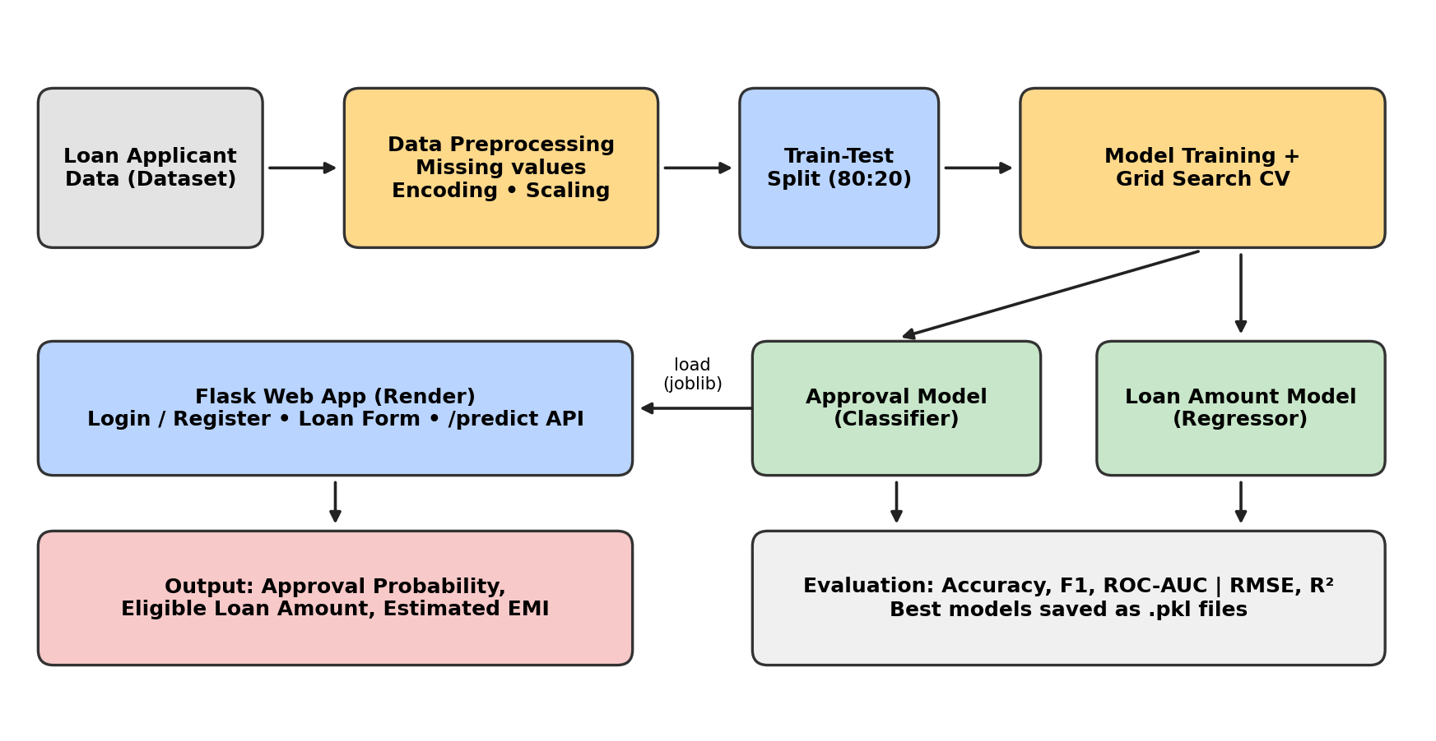
Figure 1: Proposed Project Design
The above flowchart explains the proposed workflow. It has the following steps:
- Data Collection (Loan Applicant Data): The dataset containing applicant attributes such as monthly income, employment type, credit score, existing loans, dependents, savings, loan type, requested amount and tenure is collected.
- Data Preprocessing: Missing values are handled, categorical features (Employment Type, Loan Type) are encoded, and numerical features are normalized so that they are on a uniform scale.
- Model Training: Multiple classification algorithms (for approval) and regression algorithms (for eligible loan amount) are trained on the 80% training split.
- Hyperparameter Tuning: Grid Search with 5-fold cross-validation systematically tests combinations of model parameters so that each algorithm performs optimally.
- Model Evaluation: Accuracy, Precision, Recall, F1-Score and ROC-AUC are used for the approval model; RMSE and R² Score are used for the loan amount model.
- Model Selection and Saving: The best model in each category is selected and saved with joblib as loan_approval_model.pkl and loan_amount_model.pkl.
- Deployment: The saved models are loaded by the Flask application, which exposes a login-protected form and a /predict endpoint that returns the approval probability, eligible loan amount and estimated EMI. The application is hosted on Render.

4. Dataset Overview
This dataset provides a structured representation of loan applicants and their financial profiles. It contains 1,000 records, where each record corresponds to one loan application and describes the applicant’s income, credit standing, liabilities and the loan requested, along with the final decision and sanctioned amount. . The original file has 31 columns; the ten input features listed below are used for modelling, and the dataset has no missing values.

4.1 Feature/Attribute Details
The application takes the following ten input features, exactly as expected by the /predict endpoint of the Flask app:
Table 1: Input Features of the Loan Eligibility System
# | Attribute | Type | Description
1 | monthly_income | Numerical | Applicant’s gross monthly income (in ₹). A primary indicator of repayment capacity.
2 | employment_type | Categorical | Nature of employment (e.g., Salaried, Self-Employed). Reflects income stability.
3 | credit_score | Numerical | Credit score of the applicant (typically 300–900). Higher scores indicate a better repayment history.
4 | existing_loans_count | Numerical | Number of loans the applicant is currently repaying.
5 | existing_emi_monthly | Numerical | Total monthly EMI already being paid on existing loans (in ₹). Reduces disposable income.
6 | dependents | Numerical | Number of people financially dependent on the applicant.
7 | savings_balance | Numerical | Current savings/bank balance of the applicant (in ₹). Acts as a financial buffer.
8 | loan_type | Categorical | Category of the loan requested (e.g., Home, Personal, Education, Vehicle).
9 | requested_amount | Numerical | Loan amount requested by the applicant (in ₹).
10 | tenure_months | Numerical | Repayment period requested, in months.

The models produce the following output variables:
Table 2: Output Variables of the Prediction Models
# | Output | Model | Description
1 | approval_probability | Classifier | Probability (0–1) that the loan application is “Approved”, taken from predict_proba for the “Approved” class.
2 | eligible_loan_amount | Regressor | Maximum loan amount the applicant is eligible for (in ₹), never below zero.
3 | estimated_emi | Formula | Monthly instalment calculated from the eligible amount, tenure and an annual interest rate of 10.5%.

4.2 Data Characteristics
- The dataset contains a mix of numerical features (income, credit score, EMI, savings, amounts, tenure) and categorical features (employment type and loan type).
- The target for the approval model is a categorical status with classes such as Approved / Rejected, and the target for the amount model is a continuous loan amount.
- Financial variables such as income, savings and loan amounts are typically right-skewed and lie on very different scales (for example, credit score in hundreds versus savings in lakhs), which makes scaling necessary.
- Some columns may contain missing or inconsistent values that must be addressed during preprocessing.
- Class distribution of the approval target: 91.0% approved and 9.0% rejected. The original loan_status column has three classes: Approved 52.1%, Partially Approved 38.9% and Rejected 9.0%. For the binary approval model, Approved and Partially Approved are grouped together as "Approved" (91.0%), since a sanctioned loan is a positive outcome.
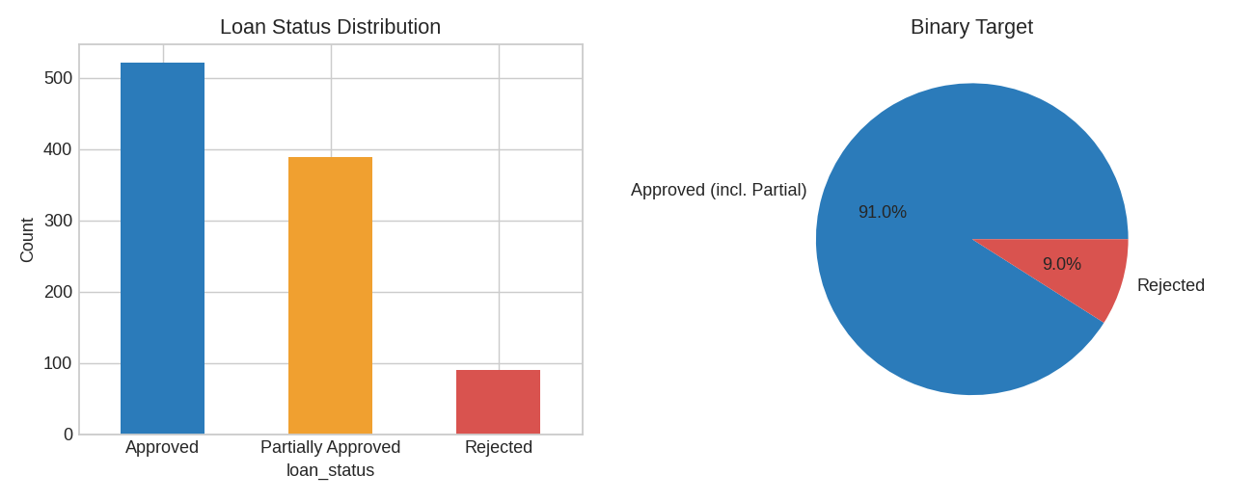
Figure 2: Loan Status Distribution and Binary Target (Approved vs Rejected)
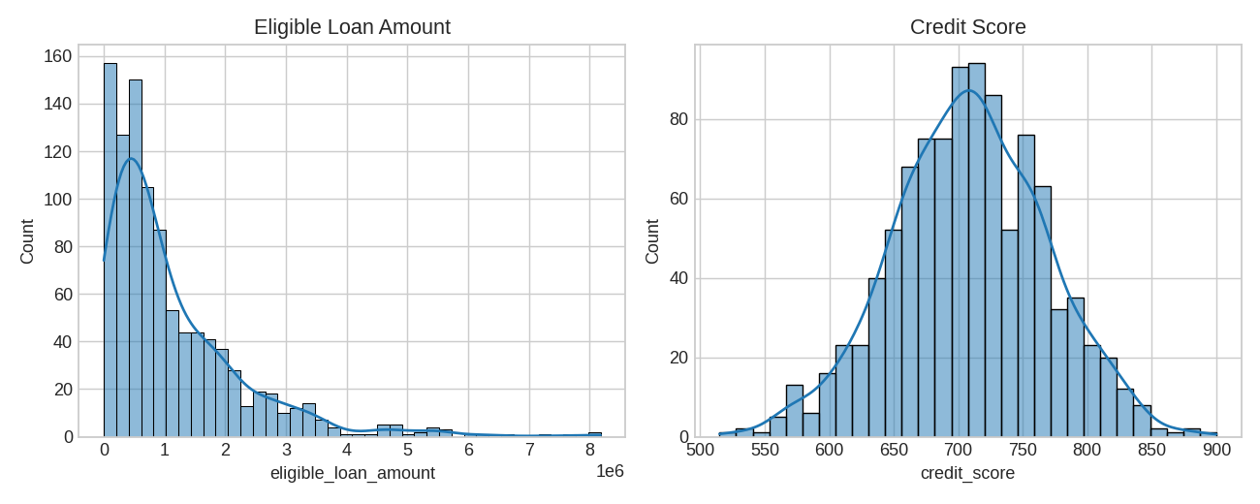
Figure 3: Distribution of Eligible Loan Amount and Credit Score

5. Data Preprocessing
Raw datasets often contain inconsistencies, missing values and attributes that are not directly suitable for machine learning models. Preprocessing is therefore a crucial step. In this project, preprocessing involved three major tasks: handling missing values, encoding categorical variables, and data normalization.

5.1 Handling Missing Values
Loan records may have missing entries in fields such as income, credit score, savings or employment type. Different strategies were employed depending on the nature of the attribute:
- Removal of Irrelevant Records: Records with extensive missing information across multiple key fields were dropped.
- Imputation: For numerical features such as monthly_income, credit_score and savings_balance, missing values were replaced with the mean (or median) of the available values. For categorical features such as employment_type and loan_type, missing entries were filled with the mode (most frequent value).
This ensured that the dataset remained consistent without losing valuable information due to excessive record deletion.

5.2 Attribute Selection
Only attributes that carry predictive value for repayment capacity were retained. Identifier-type columns (such as applicant ID or name), if present, were excluded. The final feature set consists of the ten attributes listed in Section 4.1: monthly_income, employment_type, credit_score, existing_loans_count, existing_emi_monthly, dependents, savings_balance, loan_type, requested_amount and tenure_months.

5.3 Encoding Categorical Variables
Since machine learning algorithms require numerical input, the categorical variables employment_type and loan_type were encoded into numeric form (One-Hot / Label Encoding). Because the deployed models accept a raw record containing text values for these two fields, the encoding step is stored inside the saved model pipeline, so the same transformation is automatically applied to every new applicant entered through the web form.

5.4 Data Normalization
The dataset contains attributes with widely varying scales, such as credit score (300–900), tenure (in months), and income, savings and loan amounts (in thousands or lakhs of rupees). Without normalization, distance-based and margin-based models would give undue importance to attributes with larger numerical ranges.
- To address this, Z-Score Normalization was applied to the numerical columns. It transforms each feature so that it has a mean of 0 and a standard deviation of 1:
z = (x − μ) / σ
where x is the original value, μ is the mean of the feature and σ is its standard deviation.
- Fitting the scaler on training data only and reusing it for test and live data prevents data leakage.
Preprocessing and train-test split code:
import pandas as pd
from sklearn.model_selection import train_test_split

df = pd.read_csv('loan_eligibility_emi_dataset.csv')
num_cols = ['monthly_income','credit_score','existing_loans_count','existing_emi_monthly',
'dependents','savings_balance','requested_amount','tenure_months']
cat_cols = ['employment_type','loan_type']
X = df[num_cols + cat_cols]
y_cls = (df['loan_status'] != 'Rejected').astype(int) # 1 = Approved / Partially Approved
y_reg = df['eligible_loan_amount']

X_train, X_test, yc_train, yc_test, yr_train, yr_test = train_test_split(
X, y_cls, y_reg, test_size=0.2, random_state=42, stratify=y_cls)
from sklearn.compose import ColumnTransformer
from sklearn.pipeline import Pipeline
from sklearn.preprocessing import StandardScaler, OneHotEncoder
prep = ColumnTransformer([('num', StandardScaler(), num_cols),
('cat', OneHotEncoder(handle_unknown='ignore'), cat_cols)])

5.5 EMI Calculation (Post-Processing)
After the regression model predicts the eligible loan amount, the Estimated Monthly EMI is computed in the application using the standard reducing-balance formula:
EMI = P × r × (1 + r)ⁿ / ((1 + r)ⁿ − 1)
where P is the principal (eligible loan amount), r is the monthly interest rate (annual rate 10.5% ÷ 12 ÷ 100) and n is the tenure in months. If the rate is zero, EMI is simply P ÷ n.

6. Model Training and Hyperparameter Tuning
After preprocessing, the dataset was split into training and testing sets in an 80:20 ratio (800 training samples and 200 testing samples). Two prediction tasks were handled separately:
- Task 1 – Loan Approval (Classification): predicts whether an application is Approved or not, along with the probability of approval.
- Task 2 – Eligible Loan Amount (Regression): predicts the maximum loan amount the applicant is eligible for.
Training Strategy Used:
- Train-Test Split: 80:20 ratio.
- Cross-Validation: 5-fold cross-validation was used for hyperparameter optimization.
- Grid Search: Applied to identify the best set of hyperparameters for each algorithm.

6.1 Logistic Regression (Approval Model)
Logistic Regression is a linear classification algorithm that models the probability of the positive class (“Approved”) using the sigmoid function:
P(y = 1 | x) = 1 / (1 + e^−(β₀ + β₁x₁ + … + βₙxₙ))
It is simple, fast and highly interpretable, and produces well-calibrated probabilities, which makes it a natural baseline for approval prediction. Key hyperparameter: C (inverse regularization strength). Best parameter found: C = 100.
Code:
from sklearn.linear_model import LogisticRegression
grid = GridSearchCV(Pipeline([('prep', prep), ('model', LogisticRegression(max_iter=2000, class_weight='balanced'))]),
{'model__C': [0.01, 0.1, 1, 10, 100]}, cv=5, scoring='f1', n_jobs=-1)
grid.fit(X_train, yc_train)
print('Best Parameters:', grid.best_params_)

6.2 K-Nearest Neighbour (Approval Model)
KNN is a non-parametric algorithm. A new applicant is classified according to the majority class of the K most similar applicants in the (scaled) feature space. A small K is sensitive to noise, while a large K over-smooths the decision boundary. The optimal K is chosen using 5-fold cross-validation: K = 7. Test accuracy of KNN with K = 7 is 93.00%.
Code:
from sklearn.neighbors import KNeighborsClassifier
cv_scores = []
for k in range(1, 31):
knn = Pipeline([('prep', prep), ('model', KNeighborsClassifier(n_neighbors=k))])
cv_scores.append(cross_val_score(knn, X_train, yc_train, cv=5, scoring='f1').mean())
optimal_k = list(range(1, 31))[np.argmax(cv_scores)]
print('Optimal K-Neighbors =', optimal_k)
Optimal K-Neighbors = 7
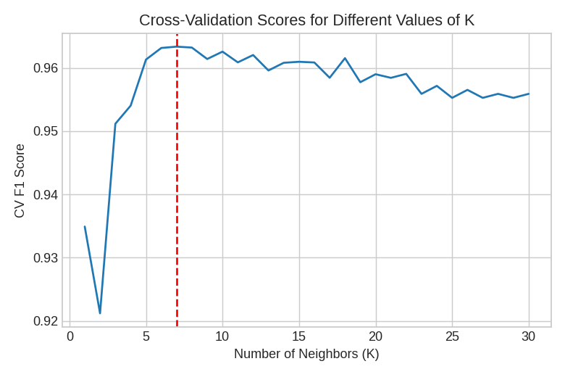
Figure 4: CV F1 Scores for Different Values of K

6.3 Random Forest (Classifier and Regressor)
Random Forest is an ensemble learning method that combines many decision trees, each trained on a random subset of the data and features. For classification, the trees vote; for regression, their predictions are averaged:
ŷ = (1/T) Σ hₜ(x), t = 1 … T
Key hyperparameters tuned with Grid Search: n_estimators (number of trees), max_depth (maximum tree depth) and min_samples_split (minimum samples needed to split a node). Best parameters found: Classifier – max_depth = None, min_samples_split = 2, n_estimators = 100; Regressor – max_depth = 20, min_samples_split = 5, n_estimators = 100. Random Forest also provides feature importance, showing which applicant attributes contribute most to the decision (such as credit score and monthly income): for approval – credit_score (48.7%), monthly_income (12.7%), requested_amount (9.4%), savings_balance (7.9%); for loan amount – requested_amount (78.6%), monthly_income (6.2%), credit_score (5.8%), loan_type (2.9%).
Code (classifier; the regressor uses RandomForestRegressor with scoring='r2'):
from sklearn.ensemble import RandomForestClassifier
param_grid = {'model__n_estimators': [100, 200],
'model__max_depth': [None, 10, 20],
'model__min_samples_split': [2, 5]}
grid = GridSearchCV(Pipeline([('prep', prep), ('model', RandomForestClassifier(random_state=42, class_weight='balanced'))]),
param_grid, cv=5, scoring='f1', n_jobs=-1)
grid.fit(X_train, yc_train)
print('Best Parameters:', grid.best_params_)
Best Parameters: {'model__max_depth': None, 'model__min_samples_split': 2, 'model__n_estimators': 100}
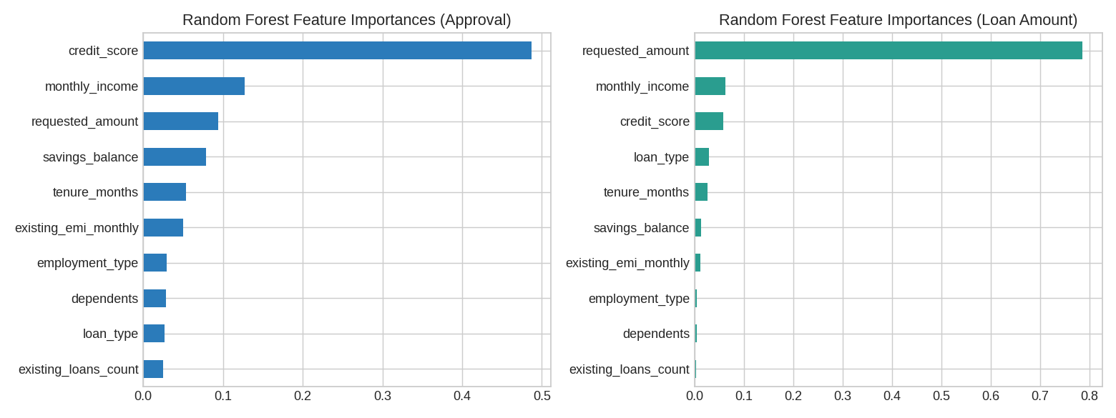
Figure 5: Feature Importances (Random Forest)

6.4 XG Boost (Classifier and Regressor)
XG Boost (eXtreme Gradient Boosting) is a powerful gradient boosting framework that uses decision trees as base learners.
- It builds trees sequentially, where each new tree corrects the errors (residuals) of the previous ensemble.
- It uses gradient descent to minimize a loss function when adding new trees.
- It includes L1 and L2 regularization to control model complexity and reduce overfitting.
- The final prediction is the sum of the predictions of all individual trees: ŷ = Σ fₖ(x), k = 1 … K.
Key hyperparameters: n_estimators (number of boosting rounds), max_depth (maximum depth of a tree) and learning_rate (shrinkage applied after each boosting step). Best parameters found: Classifier – learning_rate = 0.05, max_depth = 3, n_estimators = 100; Regressor – learning_rate = 0.1, max_depth = 3, n_estimators = 200.
Code (classifier; the regressor uses XGBRegressor with scoring='r2'):
from xgboost import XGBClassifier
param_grid = {'model__n_estimators': [100, 200],
'model__max_depth': [3, 5],
'model__learning_rate': [0.05, 0.1]}
grid = GridSearchCV(Pipeline([('prep', prep), ('model', XGBClassifier(random_state=42, eval_metric='logloss'))]),
param_grid, cv=5, scoring='f1', n_jobs=-1)
grid.fit(X_train, yc_train)
print('Best Parameters:', grid.best_params_)
Best Parameters: {'model__learning_rate': 0.05, 'model__max_depth': 3, 'model__n_estimators': 100}

6.5 Linear Regression (Loan Amount Baseline)
Linear Regression models the eligible loan amount as a linear combination of the input features:
ŷ = β₀ + β₁x₁ + β₂x₂ + … + βₙxₙ
It is simple and interpretable but struggles when relationships are non-linear, and is used as the baseline against which the ensemble regressors are compared.
Code:
from sklearn.linear_model import LinearRegression
lin_reg = Pipeline([('prep', prep), ('model', LinearRegression())])
lin_reg.fit(X_train, yr_train)
y_pred = lin_reg.predict(X_test)
print('RMSE:', root_mean_squared_error(yr_test, y_pred))
print('R2 Score:', r2_score(yr_test, y_pred))
RMSE: 662737.77
R2 Score: 0.6546
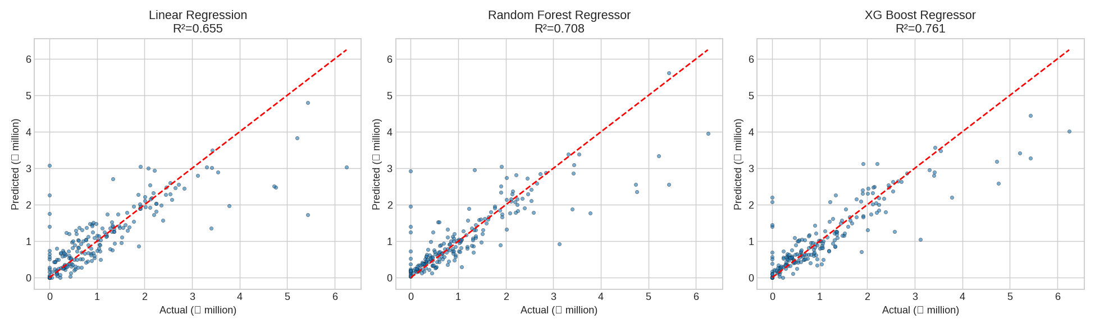
Figure 6: Predicted vs. Actual Loan Amount (Linear Regression, Random Forest, XG Boost)
Sample training code (Grid Search with 5-fold cross-validation):
from sklearn.model_selection import GridSearchCV
from sklearn.ensemble import RandomForestClassifier

param_grid = {'n_estimators': [100, 200, 300],
'max_depth': [None, 10, 20],
'min_samples_split': [2, 5, 10]}

grid = GridSearchCV(RandomForestClassifier(random_state=42),
param_grid, cv=5, scoring='f1', n_jobs=-1)
grid.fit(X_train, y_train)
print('Best Parameters:', grid.best_params_)

7. Model Evaluation and Selection
After training the models and tuning their hyperparameters, model evaluation and selection are the final critical steps. Each model is assessed on the unseen 20% test set to measure how well it generalizes, and the most accurate and reliable model is chosen for deployment.

7.1 Model Evaluation
Metrics for the Approval Model (Classification):
- Accuracy: proportion of applications classified correctly = (TP + TN) / (TP + TN + FP + FN).
- Precision: of all applications predicted “Approved”, the fraction that were truly approved = TP / (TP + FP).
- Recall: of all truly approved applications, the fraction the model identified = TP / (TP + FN).
- F1-Score: harmonic mean of precision and recall = 2 × (Precision × Recall) / (Precision + Recall).
- ROC-AUC: ability of the model to separate approved from rejected applications across all probability thresholds; 1.0 is perfect and 0.5 is random guessing.
Metrics for the Loan Amount Model (Regression):
- R² Score (Coefficient of Determination): proportion of variance in the eligible loan amount explained by the model. R² = 1 − Σ(yᵢ − ŷᵢ)² / Σ(yᵢ − ȳ)². A score of 1.0 is a perfect fit; 0.0 means no better than predicting the mean.
- Root Mean Squared Error (RMSE): square root of the average squared difference between predicted and actual amounts. RMSE = √((1/N) Σ(yᵢ − ŷᵢ)²). It penalizes large errors and is expressed in the same unit (₹) as the target.

7.2 Results
Approval Model (Classification) on the test set:
Table 3: Performance of the Approval (Classification) Models on the Test Set
Model | Accuracy | Precision | Recall | F1 | ROC-AUC
Logistic Regression | 83.00% | 0.9684 | 0.8407 | 0.9000 | 0.8895
KNN (K = 7) | 93.00% | 0.9330 | 0.9945 | 0.9628 | 0.8321
Random Forest Classifier | 94.00% | 0.9381 | 1.0000 | 0.9681 | 0.9045
XG Boost Classifier | 95.00% | 0.9479 | 1.0000 | 0.9733 | 0.9246

Loan Amount Model (Regression) on the test set:
Table 4: Performance of the Loan Amount (Regression) Models on the Test Set
Model | R² Score | RMSE
Linear Regression | 0.6546 | 662,738
Random Forest Regressor | 0.7082 | 609,143
XG Boost Regressor | 0.7609 | 551,410

7.3 Model Selection
The XG Boost Classifier was selected as the final approval model because it achieved the highest Accuracy/F1-Score (95.00% accuracy, 97.33% F1) and ROC-AUC (0.9246) among the models compared. The XG Boost Regressor was selected as the final loan amount model because it recorded the highest R² Score (0.7609) and the lowest RMSE (₹551,410).
Ensemble methods such as Random Forest and XG Boost generally perform best on tabular financial data because they capture non-linear interactions (for example, between income, existing EMI and credit score) and are robust to differences in feature scale. Both selected models were exported using joblib as loan_approval_model.pkl and loan_amount_model.pkl.
Evaluation code:
from sklearn.metrics import accuracy_score, precision_score, recall_score, f1_score, roc_auc_score
y_pred = best_clf.predict(X_test); y_prob = best_clf.predict_proba(X_test)[:, 1]
print('Accuracy:', accuracy_score(yc_test, y_pred), 'F1:', f1_score(yc_test, y_pred),
'ROC-AUC:', roc_auc_score(yc_test, y_prob))
y_hat = best_reg.predict(X_test).clip(min=0)
print('R2:', r2_score(yr_test, y_hat), 'RMSE:', root_mean_squared_error(yr_test, y_hat))
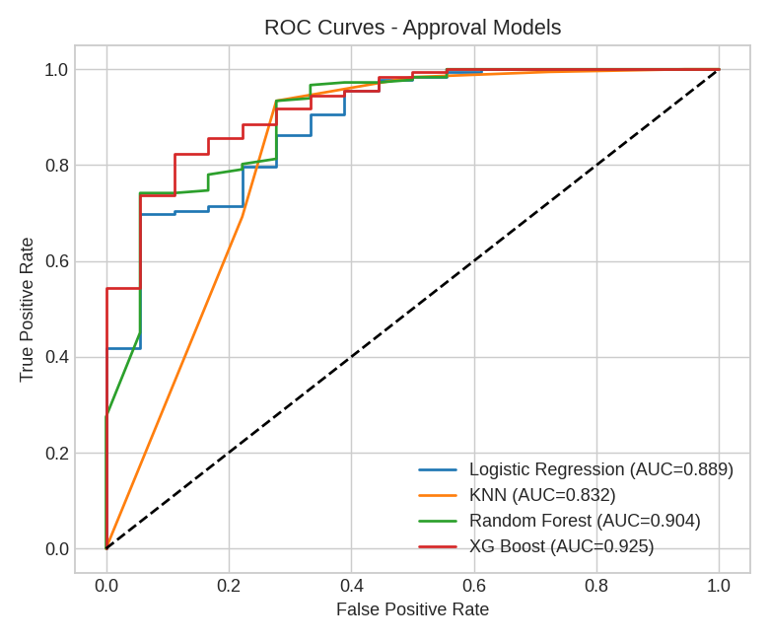
Figure 7: ROC Curves of the Approval Models
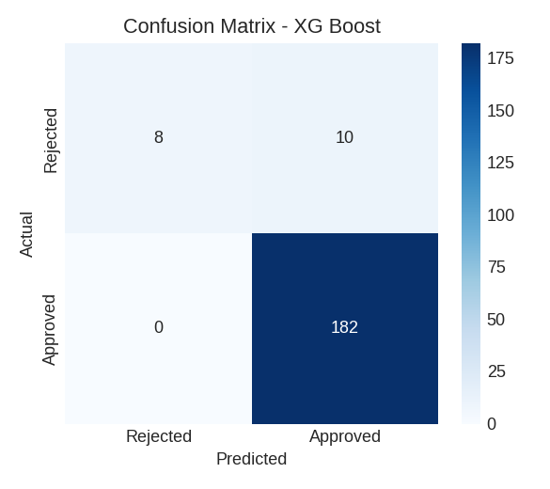
Figure 8: Confusion Matrix of the Best Classifier (XG Boost Classifier)
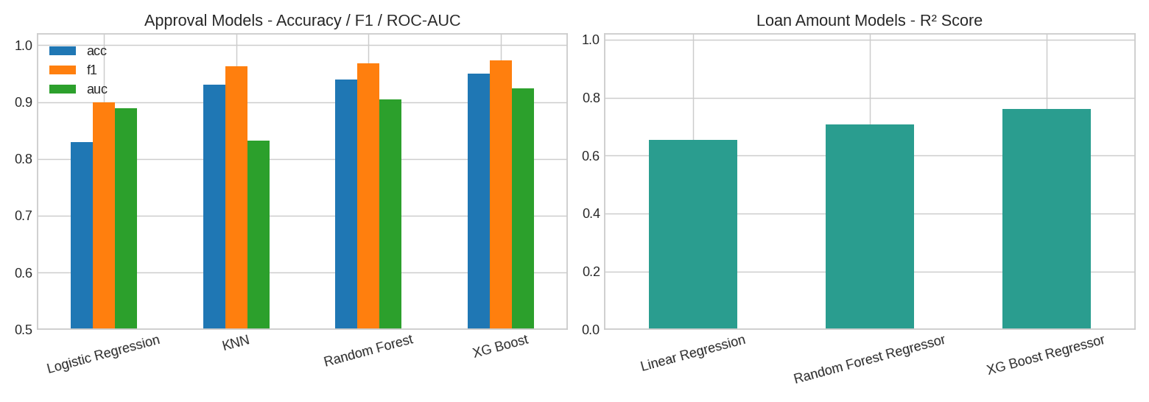
Figure 9: Comparison of Models (Classification and Regression)

8. Web Application Implementation
The trained models are served through a Flask web application (app.py) deployed on Render at https://loan-eligibility-project-sstz.onrender.com/. The application has the following components:

8.1 Technology Stack
- Backend: Python, Flask.
- Machine Learning: scikit-learn models loaded with joblib; data handled with pandas and NumPy.
- Security: Werkzeug generate_password_hash / check_password_hash for password hashing; Flask session for login state.
- Storage: user credentials are stored in data/users.json; models are stored in the models/ folder.
- Frontend: HTML templates (login.html, register.html, index.html) rendered with Jinja2.

8.2 Application Routes
Table 5: Application Routes of the Flask Web Application
Route | Method | Purpose
/register | GET, POST | Creates a new account. Validates that username and password are provided, passwords match, and the username is unique (case-insensitive); the password is stored as a hash.
/login | GET, POST | Authenticates the user by comparing the entered password with the stored hash and starts a session.
/logout | GET | Clears the session and redirects to the login page.
/ | GET | Protected home page showing the loan eligibility form; redirects to login if the user is not signed in.
/predict | POST | Accepts the ten input features as JSON, validates them, runs both models and returns the results as JSON.

8.3 Prediction Workflow
- The logged-in user fills in the loan form and submits the ten features.
- The /predict endpoint checks the session (401 if unauthorized), verifies the models are loaded and validates that all required fields are present (400 if missing).
- Inputs are converted to numeric/text types and arranged into a single-row pandas DataFrame.
- The approval model’s predict_proba returns the probability of the “Approved” class, rounded to four decimals.
- The amount model’s predict returns the eligible loan amount, clipped at zero and rounded to two decimals.
- The EMI is calculated for the eligible amount and tenure at 10.5% annual interest.
- The JSON response contains approval_probability, eligible_loan_amount and estimated_emi, which are displayed on the page.
Example response:
{
"approval_probability": 0.8735,
"eligible_loan_amount": 1250000.0,
"estimated_emi": 26886.42
}

Error handling is included for missing or invalid JSON (400), unauthorized access (401) and internal prediction failures (500).

9. Conclusion
This project successfully developed and deployed a Loan Eligibility Prediction System that combines machine learning with a secure web interface. By taking ten easily available applicant details as input, the system instantly returns the probability of loan approval, the eligible loan amount and the estimated monthly EMI, giving lenders a fast pre-screening tool and giving applicants clarity before they apply.
Careful data preprocessing, including handling of missing values, encoding of Employment Type and Loan Type, and Z-Score normalization, prepared the data for modelling. Several algorithms were trained and tuned using Grid Search with 5-fold cross-validation, and the best classifier and regressor were chosen using Accuracy, F1-Score, ROC-AUC, RMSE and R² Score. The selected models achieved an accuracy of 95.00% (F1-Score 97.33%, ROC-AUC 0.9246) for loan approval prediction using the XG Boost Classifier, and an R² Score of 0.7609 (RMSE ≈ ₹551,410) for eligible loan amount prediction using the XG Boost Regressor, showing that the approach is reliable for loan screening.

Future Scope
- Integrating real-time credit bureau data and bank statement analysis to improve accuracy.
- Adding explainability (for example SHAP values) so applicants can see why they were approved or rejected.
- Using a database such as PostgreSQL instead of a JSON file for user data, and adding an admin dashboard for loan officers.
- Making the interest rate dynamic according to loan type, tenure and credit score instead of a fixed 10.5%.
- Auditing the models for fairness and bias, and periodically retraining them with new data.

10. References
Project Links
- Live Web Application: https://loan-eligibility-project-sstz.onrender.com/
- GitHub Repository (24501A05M4): https://github.com/sontirohit999/Loan_Eligibilty
Documentation
- Scikit-Learn Documentation: https://scikit-learn.org/stable/
- Flask Documentation: https://flask.palletsprojects.com/
- XGBoost Documentation: https://xgboost.readthedocs.io/
- Werkzeug Security Utilities: https://werkzeug.palletsprojects.com/

